
Family doctor services registration GMS1

Patient’s details Please complete in BLOCK CAPITALS and tick |  | as appropriate
Mr Mrs Miss Ms Surname

Date of birth
NHS No.

First names

Previous surname/s

Male Female
Town and country of birth

Home address

Postcode Telephone number

Please help us trace your previous medical records by providing the following information Your previous address in UK Name of previous GP practice while at that address

Address of previous GP practice

If you are from abroad
Your frst UK address where registered with a GP

If previously resident in UK, Date you frst came date of leaving to live in UK
Were you ever registered with an Armed Forces GP
Please indicate if you have served in the UK Armed Forces and/or been registered with a Ministry of Defence GP in the UK or overseas: Regular Reservist Veteran Family Member (Spouse, Civil Partner, Service Child)
Address before enlisting:

Postcode
Service or Personnel number: Enlistment date: DD MM YY Discharge date: DD MM YY (if applicable)
Footnote: These questions are optional and your answers will not affect your entitlement to register or receive services from the NHS but may improve access to some NHS priority and service charities services.

If you need your doctor to dispense medicines and appliances*
I live more than 1.6km in a straight line from the nearest chemist
I would have serious diffculty in getting them from a chemist

*Not all doctors are authorised to dispense medicines

Signature of Patient Signature on behalf of patient

Date________/_________/_________

What is your ethnic group?
Please tick one box that best describes your ethnic group or background from the options below:
White: British Irish Irish Traveller Traveller Gypsy/Romany Polish
Any other white background (please write in): ................................................................................................................................................................................................................................

Mixed: White and Black Caribbean White and Black African White and Asian
Any other Mixed background (please write in): ...............................................................................................................................................................................................................................

Asian or Asian British: Indian Pakistani Bangladeshi
Any other Asian background (please write in): .................................................................................................................................................................................................................................

Black or Black British: Caribbean African Somali Nigerian
Any other Black background (please write in): .................................................................................................................................................................................................................................

Other ethnic group: Chinese Filipino
Any other ethnic group (please write in): ................................................................................................................................................................................................................................................

Not stated:
Not Stated should be used where the PERSON has been given the opportunity to state their ETHNIC CATEGORY but chose not to.

NHS England use only Patient registered for GMS Dispensing

062021_006 Product Code: GMS1

GMS1 - Family Doctor Services Registration - Tearoff.indd 1 25/06/2021 10:14

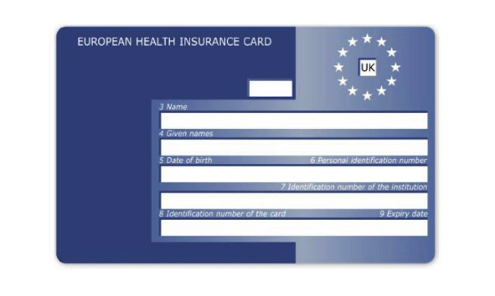

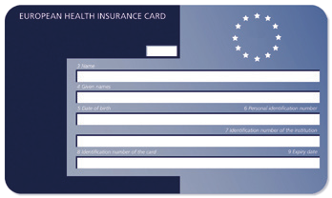
Family doctor services registration GMS1

SUPPLEMENTARY QUESTIONS – These questions and the patient declaration are optional and your answers will not affect your entitlement to register or receive services from your GP.
PATIENT DECLARATION for all patients who are not ordinarily resident in the UK
Anybody in England can register with a GP practice and receive free medical care from that practice.
However, if you are not ‘ordinarily resident’ in the UK you may have to pay for NHS treatment outside of the GP practice. Being ordinarily resident broadly means living lawfully in the UK on a properly settled basis for the time being. In most cases, nationals of countries outside the European Economic Area must also have the status of ‘indefnite leave to remain’ in the UK.
Some services, such as diagnostic tests of suspected infectious diseases and any treatment of those diseases are free of charge to all people, while some groups who are not ordinarily resident here are exempt from all treatment charges.
More information on ordinary residence, exemptions and paying for NHS services can be found in the Visitor and Migrant
patient leafet, available from your GP practice.
You may be asked to provide proof of entitlement in order to receive free NHS treatment outside of the GP practice, otherwise you may be charged for your treatment. Even if you have to pay for a service, you will always be provided with any immediately necessary or urgent treatment, regardless of advance payment.
The information you give on this form will be used to assist in identifying your chargeable status, and may be shared, including with NHS secondary care organisations (e.g. hospitals) and NHS Digital, for the purposes of validation, invoicing and cost recovery. You may be contacted on behalf of the NHS to confrm any details you have provided.
Please tick one of the following boxes:
a) I understand that I may need to pay for NHS treatment outside of the GP practice

b) I understand I have a valid exemption from paying for NHS treatment outside of the GP practice. This includes for example, an EHIC, or payment of the Immigration Health Charge (“the Surcharge”), when accompanied by a valid visa. I can provide documents to support this when requested
c) I do not know my chargeable status
I declare that the information I give on this form is correct and complete. I understand that if it is not correct, appropriate action may be taken against me.
A parent/guardian should complete the form on behalf of a child under 16.
Signed: |  |  |  | Date: |  | DD MM YY
Print name: |  |  |  | Relationship to patient:
On behalf of:
Complete this section if you live in an EU country, or have moved to the UK to study or retire, or if you live in the UK but work in another EEA member state. Do not complete this section if you have an EHIC issued by the UK.
NON-UK EUROPEAN HEALTH INSURANCE CARD (EHIC), PROVISIONAL REPLACEMENT CERTIFICATE (PRC) DETAILS and S1 FORMS
Do you have a non-UK EHIC or PRC? |  | YES: NO: |  |  | If yes, please enter details from your EHIC or PRC below:
If you are visiting from another EEA country and do not hold a current EHIC (or Provisional Replacement Certifcate (PRC))/S1, you may be billed for the cost of any treatment received outside of the GP practice, including at a hospital. |  | Country Code:
 |  | 3: Name
 |  | 4: Given Names
 |  | 5: Date of Birth | DD MM YYYY
 |  | 6: Personal Identifcation Number
 |  | 7: Identifcation number of the institution
 |  | 8: Identifcation number of the card
 |  | 9: Expiry Date | DD MM YYYY
PRC validity period (a) From: |  | DD MM YYYY | (b) To: |  |  |  | DD MM YYYY
Please tick if you have an S1 (e.g. you are retiring to the UK or you have been posted here by your employer for work or you live in the UK but work in another EEA member state). Please give your S1 form to the practice staff.
How will your EHIC/PRC/S1 data be used? By using your EHIC or PRC for NHS treatment costs your EHIC or PRC data and GP appointment data will be shared with NHS secondary care (hospitals) and NHS Digital solely for the purposes of cost recovery. Your clinical data will not be shared in the cost recovery process.
Your EHIC, PRC or S1 information will be shared with Business Service Authority for the purpose of recovering your NHS costs from your home country.

To be completed by the GP Practice
Practice Name Practice Code

I have accepted this patient for general medical services on behalf of the practice

I will dispense medicines/appliances to this patient subject to NHS England approval.

I declare to the best of my belief this information is correct Practice Stamp

Authorised Signature
Name Date _______/_______/_______

GMS1 - Family Doctor Services Registration - Tearoff.indd 2 25/06/2021 10:14

